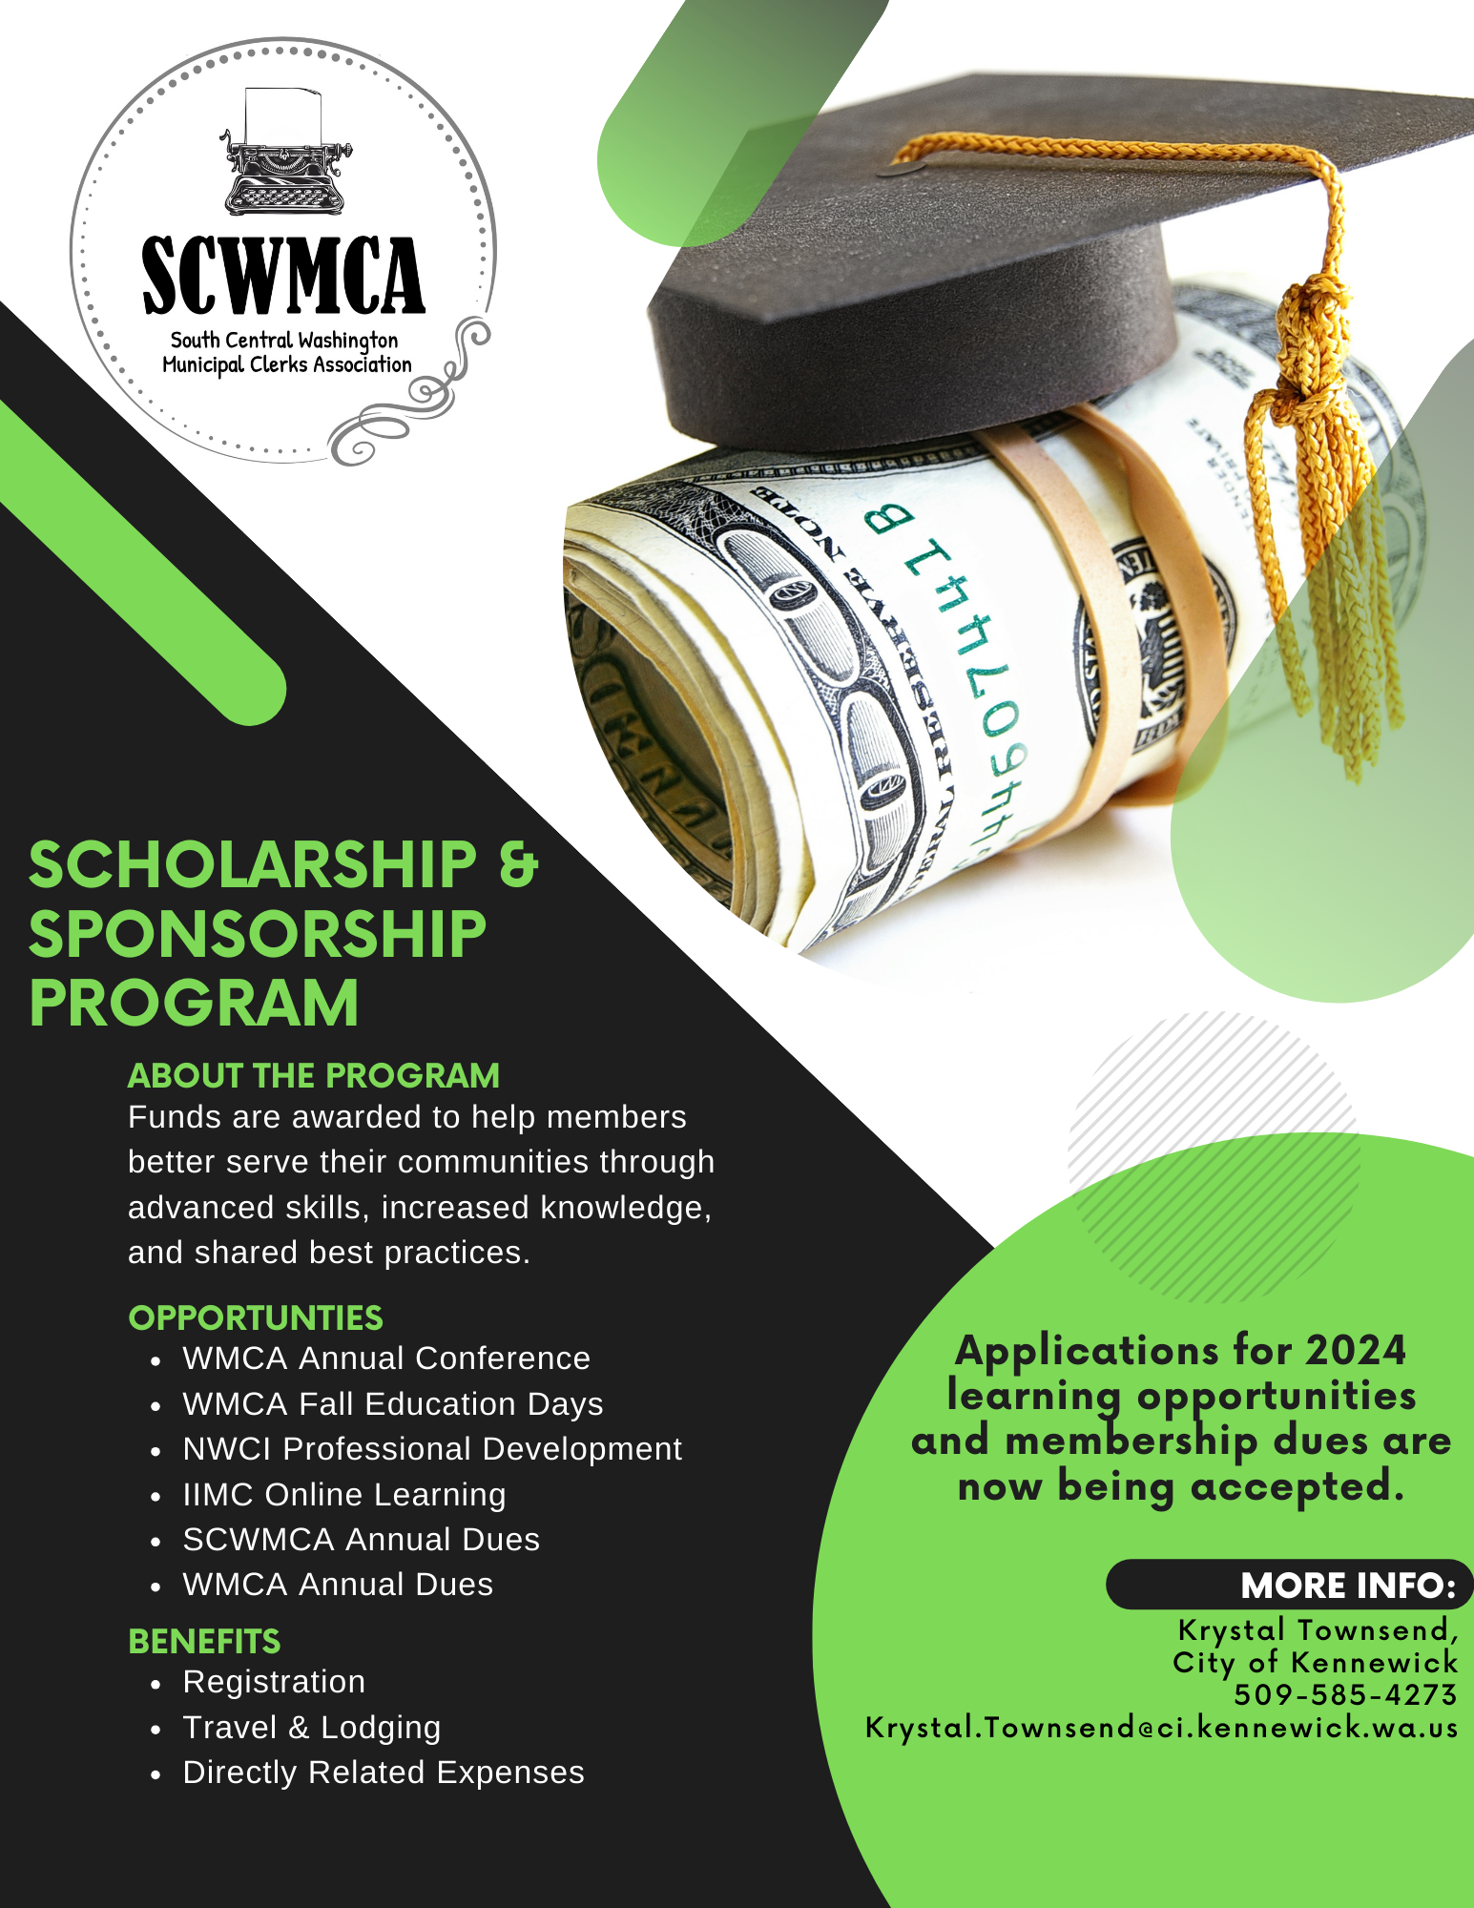

**2024 SCHOLARSHIP & SPONSORSHIP OPPORTUNITIES**

|  |  |  |  |  |  |
| --- | --- | --- | --- | --- | --- |
| **HOST** | **DESCRIPTION** | **DATES** | **MAXIMUM REIMBURSED** | **APPLICATION**  **DEADLINE** | **PROVIDE PROOF OF ATTENDANCE NO LATER THAN . . .** |
| WMCA | Annual Conference | March 19 – 22, 2024 | $500 | **02/5/2024** | **04/30/2024** |
| IIMC | 🟅Annual Conference | May 19 – 22, 2024 | $500 | **04/15/2024** | **06/30/2024** |
| NWCI | PD I, II, III or IV | June 2024 | $500 | **05/15/2024** | **08/31/2024** |
| WMCA | Fall Education Days | September 2024 | $350 | **08/15/2024** | **10/31/2024** |
| IIMC | 🟅Online Learning | Jan 1 – Sep 30, 2024 | $350 | **10/15/2024** | **11/30/2024** |
| SCWMCA | 2024 Annual Dues | Jan 1 – Sep 30, 2024 | $50 | **10/15/2024** | **N/A** |
| WMCA | 2024 Annual Dues | Jan 1 – Sep 30, 2024 | $50 | **10/15/2024** | **N/A** |

**\*The maximum reimbursable amounts listed are per person, PER YEAR.**

Scholarship award(s) will be selected by the SCWMCA Scholarship Committee. These are reimbursable scholarships. The amount reimbursed will not exceed the actual, eligible expenses incurred. IRS regulations dictate reimbursement for mileage and meals.

🟅Subject to a*pproval by SCWMCA membership at the January 17, 2024, meeting.*

**The following criteria apply*:***

1. The applicant must be a member in good standing of the Washington Municipal Clerks Association and the South Central Washington Municipal Clerks Association. (Applicant may join at the time of application.)
2. Preference will be given by SCWMCA to first-time scholarship applicants.
3. **Each person may submit only one application for 2024 opportunities.**
4. Applications must be complete when submitted and must be submitted by the application deadline.
5. Specific criteria will be used to consider scholarship applications. Applications are considered by need, commitment to attend, completeness of application, and by order of date received.
6. **A letter from either the applicant’s direct supervisor or Mayor supporting their application for training conferences and online learning opportunities is required.**
7. Supporting materials must be submitted no later than the deadlines listed above including any receipts for airfare, lodging, parking, registration, enrollment, conference agenda, and syllabus (for IIMC online learning opportunities).
8. Scholarships are non-transferable and will be reimbursed after receipt of the recipient’s supporting materials/proof of attendance.
9. A limited amount of scholarship funds are available; an eligible applicant may not receive funding if all available funds have been exhausted.

**Anyone desiring further information should contact:**

Krystal Townsend, CMC

City Clerk, City of Kennewick

PO Box 6108; Kennewick, WA 99336

(509) 585-4273 | [Krystal.Townsend@ci.kennewick.wa.us](mailto:Krystal.Townsend@ci.kennewick.wa.us)

|  |  |  |  |  |  |  |  |  |  |
| --- | --- | --- | --- | --- | --- | --- | --- | --- | --- |
| **WMCA Annual Conference Scholarship Application**  March 2024 – Yakima, Washington | | | | | | | | | |
| **Name:** |  | | | | | | | | |
| **Job Title:** |  | | | | **Since (Date):** | |  | | |
| **Employer:** |  | | | | | | | | |
| **Mailing Address:** |  | | | | | | | | |
| **Email:** |  | | | | **Work Phone:** | |  | | |
| **List Your Primary Duties & Responsibilities:** | | | | | | | | | |
| **Total Requested*:** |  | | | | **Days Attended:** | | March 19 20 21 22 | | |
| Registration: |  | | | | Airfare/Mileage: | |  | | |
| Lodging: |  | | | | Incidentals: | |  | | |
| Breakfast(s): |  | | | | Lunch(es): | |  | | |
| Dinner(s): |  | | | | Parking: | |  | | |
| **Please complete the following:** | | | | | | | | | |
| Have you previously been awarded a scholarship from SCWMCA? | | | | | | | | Yes | No |
| If yes, please describe: | | |  | | | | | | |
| Has your agency provided you with other training opportunities in 2024? | | | | | | | | Yes | No |
| If yes, please describe: | | |  | | | | | | |
| When did you become a member of WMCA? | | | |  | | | | | |
| Describe your involvement with WMCA: | | | |  | | | | | |
| Describe your involvement with SCWMCA: | | | |  | | | | | |
| **i have attached the following: Letter of Support:** | | | | | | | | | |
| **please make the reimbursement payable to:** | | | | | | | | | |
| **My agency:** | | **Me, personally**:** | | **Address:** | |  | | | |
|  | | *\*\*Attach proof that you paid for this training out of pocket and were not reimbursed by your agency.* | | | | | | | |

**on or before FEBRUARY 15, 2024, Send your completed application packet to:**

[krystal.townsend@ci.kennewick.wa.us](mailto:krystal.townsend@ci.kennewick.wa.us) or by mail to: Krystal Townsend, City Clerk, City of Kennewick; PO Box 6108; Kennewick, WA 99336

I hereby apply for scholarship funds for my attendance at the 2024 WMCA Annual Conference. I attest that I am a WMCA and SCWMCA member in good standing and the information submitted in the application is true and correct to the best of my knowledge. **I understand that if I do not file my post-attendance documentation on or before April 30, 2024, any funds awarded to me will be forfeited.**

**Signature:** **Date**:

|  |  |  |  |  |  |  |  |  |  |
| --- | --- | --- | --- | --- | --- | --- | --- | --- | --- |
| **IIMC Annual Conference Scholarship Application**  ***(TENTATIVE: PENDING APPROVAL BY SCWMCA MEMBERSHIP 1-17-2024)***  May 2024 – Calgary, Alberta, Canada | | | | | | | | | |
| **Name:** |  | | | | | | | | |
| **Job Title:** |  | | | | **Since (Date):** | |  | | |
| **Employer:** |  | | | | | | | | |
| **Mailing Address:** |  | | | | | | | | |
| **Email:** |  | | | | **Work Phone:** | |  | | |
| **List Your Primary Duties & Responsibilities:** | | | | | | | | | |
| **Total Requested*:** |  | | | | **Days Attended:** | | May 19 20 21 22 | | |
| Registration: |  | | | | Airfare/Mileage: | |  | | |
| Lodging: |  | | | | Incidentals: | |  | | |
| Breakfast(s): |  | | | | Lunch(es): | |  | | |
| Dinner(s): |  | | | | Parking: | |  | | |
| **Please complete the following:** | | | | | | | | | |
| Have you previously been awarded a scholarship from SCWMCA? | | | | | | | | Yes | No |
| If yes, please describe: | | |  | | | | | | |
| Has your agency provided you with other training opportunities in 2024? | | | | | | | | Yes | No |
| If yes, please describe: | | |  | | | | | | |
| When did you become a member of WMCA? | | | |  | | | | | |
| Describe your involvement with WMCA: | | | |  | | | | | |
| Describe your involvement with SCWMCA: | | | |  | | | | | |
| **i have attached the following: Letter of Support:** | | | | | | | | | |
| **please make the reimbursement payable to:** | | | | | | | | | |
| **My agency:** | | **Me, personally**:** | | **Address:** | |  | | | |
|  | | *\*\*Attach proof that you paid for this training out of pocket and were not reimbursed by your agency.* | | | | | | | |

**on or before April 15, 2024, Send your completed application packet to:**

[krystal.townsend@ci.kennewick.wa.us](mailto:krystal.townsend@ci.kennewick.wa.us) or by mail to: Krystal Townsend, City Clerk, City of Kennewick; PO Box 6108; Kennewick, WA 99336

I hereby apply for scholarship funds for my attendance at the 2024 WMCA Annual Conference. I attest that I am a WMCA and SCWMCA member in good standing and the information submitted in the application is true and correct to the best of my knowledge. **I understand that if I do not file my post-attendance documentation on or before JUNE 30, 2024, any funds awarded to me will be forfeited.**

**Signature:** **Date**:

|  |  |  |  |  |  |  |  |  |  |  |
| --- | --- | --- | --- | --- | --- | --- | --- | --- | --- | --- |
| **Northwest Clerk’s Institute Professional Development Academy Scholarship Application**  June 2024 – Tacoma, Washington | | | | | | | | | | |
| **Name:** |  | | | | | | | | | |
| **Job Title:** |  | | | | **Since (Date):** | | |  | | |
| **Employer:** |  | | | | | | | | | |
| **Mailing Address:** |  | | | | | | | | | |
| **Email:** |  | | | | **Work Phone:** | | |  | | |
| **List Your Primary Duties & Responsibilities:** | | | | | | | | | | |
| **Total Requested*:** |  | | | | **Session:** | | | PD I PD II PD III PD IV | | |
| Registration: |  | | | | Airfare/Mileage: | |  | | | |
| Lodging: |  | | | | Incidentals: | |  | | | |
| Breakfast(s): |  | | | | Lunch(es): | |  | | | |
| Dinner(s): |  | | | | Parking: | |  | | | |
| **Please complete the following:** | | | | | | | | | | |
| Have you previously been awarded a scholarship from SCWMCA? | | | | | | | | | Yes | No |
| If yes, please describe: | | |  | | | | | | | |
| Has your agency provided you with other training opportunities in 2024? | | | | | | | | | Yes | No |
| If yes, please describe: | | |  | | | | | | | |
| When did you become a member of WMCA? | | | |  | | | | | | |
| Describe your involvement with WMCA: | | | |  | | | | | | |
| Describe your involvement with SCWMCA: | | | |  | | | | | | |
| **i have attached the following: Letter of Support:** | | | | | | | | | | |
| **please make the reimbursement payable to:** | | | | | | | | | | |
| **My agency:** | | **Me, personally**:** | | **Address:** | |  | | | | |
|  | | *\*\*Attach proof that you paid for this training out of pocket and were not reimbursed by your agency.* | | | | | | | | |

**on or before mAY 15, 2024, Send your completed application packet to:**

[krystal.townsend@ci.kennewick.wa.us](mailto:krystal.townsend@ci.kennewick.wa.us) or by mail to: Krystal Townsend, City Clerk, City of Kennewick; PO Box 6108; Kennewick, WA 99336

I hereby apply for scholarship funds for my participation in the 2024 Northwest Clerk’s Institute Professional Development Academy. I attest that I am a WMCA and SCWMCA member in good standing and the information submitted in the application is true and correct to the best of my knowledge. **I understand that if I do not file my post-attendance documentation on or before AUGUST 31, 2024, any funds awarded to me will be forfeited.**

**Signature:** **Date**:

|  |  |  |  |
| --- | --- | --- | --- |
| **WMCA Fall Education Days Scholarship Application**  September 2024 | | | |
| **Name:** |  | | |
| **Job Title:** |  | **Since (Date):** |  |
| **Employer:** |  | | |
| **Mailing Address:** |  | | |
| **Email:** |  | **Work Phone:** |  |
| **List Your Primary Duties & Responsibilities:** | | | |
| **Total Requested*:** |  | Airfare/Mileage: |  |
| Lodging: |  | Registration: |  |
| Breakfast(s): |  | Lunch(es): |  |
| Dinner(s): |  | Parking: |  |

*\*Meals and mileage are subject to IRS regulations. Please do not include meals which are covered in the cost of conference registration (such as lunch).* ***Estimates are acceptable for application purposes****.*

|  |  |  |  |  |  |  |
| --- | --- | --- | --- | --- | --- | --- |
| **Please complete the following:** | | | | | | |
| Have you previously been awarded a scholarship from SCWMCA? | | | | | Yes | No |
| If yes, please describe: | |  | | | | |
| Has your agency provided you with other training opportunities in 2024? | | | | | Yes | No |
| If yes, please describe: | |  | | | | |
| When did you become a member of WMCA? | | |  | | | |
| Describe your involvement with WMCA: | | |  | | | |
| Describe your involvement with SCWMCA: | | |  | | | |
| **i have attached the following: Letter of Support:** | | | | | | |
| **please make the reimbursement payable to:** | | | | | | |
| **My agency:** | **Me, personally**:** | | **Address:** |  | | |
|  | *\*\*Attach proof that you paid for this training out of pocket and were not reimbursed by your agency.* | | | | | |

**on or before AUGUST 15, 2024, Send completed applications to:**

[krystal.townsend@ci.kennewick.wa.us](mailto:krystal.townsend@ci.kennewick.wa.us) or by mail to: Krystal Townsend, City Clerk, City of Kennewick; PO Box 6108; Kennewick, WA 99336

I hereby apply for scholarship funds to attend the 2024 WMCA Mini Fall Conference. I attest that I am a WMCA and SCWMCA member in good standing and the information submitted in the application is true and correct to the best of my knowledge. **I understand that if I do not file my post-attendance documentation on or before October 31, 2024, any funds awarded to me will be forfeited.**

**Signature:** **Date**:

|  |  |  |  |  |  |  |  |  |  |
| --- | --- | --- | --- | --- | --- | --- | --- | --- | --- |
| **2024 IIMC Online Learning Opportunity Scholarship Application**  ***(TENTATIVE: PENDING APPROVAL BY SCWMCA MEMBERSHIP 1-17-2024)***  <https://www.iimc.com/131/Online-Learning-Opportunities> | | | | | | | | | |
| **Name:** |  | | | | | | | | |
| **Job Title:** |  | | | | **Since (Date):** | |  | | |
| **Employer:** |  | | | | | | | | |
| **Mailing Address:** |  | | | | | | | | |
| **Email:** |  | | | | **Work Phone:** | |  | | |
| **List Your Primary Duties & Responsibilities:** | | | | | | | | | |
| **Course Title:** |  | | | | | | | | |
| **Beginning Date:** |  | | | | **Completion Date:** | |  | | |
| **CMC/MMC Points:** |  | | | | **Total Requested**🟅**:** | |  | | |
| **Please complete the following:** | | | | | | | | | |
| Have you previously been awarded a scholarship from SCWMCA? | | | | | | | | Yes | No |
| If yes, please describe: | | |  | | | | | | |
| Has your agency provided you with other training opportunities in 2024? | | | | | | | | Yes | No |
| If yes, please describe: | | |  | | | | | | |
| When did you become a member of WMCA? | | | |  | | | | | |
| Describe your involvement with WMCA: | | | |  | | | | | |
| Describe your involvement with SCWMCA: | | | |  | | | | | |
| **i have attached the following: Letter of Support:** | | | | | | | | | |
| **please make the reimbursement payable to:** | | | | | | | | | |
| **My agency:** | | **Me, personally**:** | | **Address:** | |  | | | |
|  | | *\*\*Attach proof that you paid for this training out of pocket and were not reimbursed by your agency.* | | | | | | | |

**🟅*This award requires approval of 2/3 of the membership present at the October 2024 SCWMCA meeting.***

**on or before OCTOBER 15, 2024, Send your completed application packet to:**

[krystal.townsend@ci.kennewick.wa.us](mailto:krystal.townsend@ci.kennewick.wa.us) or by mail to: Krystal Townsend, City Clerk, City of Kennewick; PO Box 6108; Kennewick, WA 99336

I hereby apply for scholarship funds for my participation in an IIMC Online Learning Opportunity. I attest that I am a WMCA and SCWMCA member in good standing and the information submitted in the application is true and correct to the best of my knowledge. **I understand that if I do not file my post-attendance documentation on or before NOVEMBER 30, 2024, any funds awarded to me will be forfeited.**

**Signature:** **Date**:

|  |  |  |  |  |  |  |  |  |  |
| --- | --- | --- | --- | --- | --- | --- | --- | --- | --- |
| **2024 Association Dues Sponsorship Application**  **SCWMCA or WMCA** | | | | | | | | | |
| **Name:** |  | | | | | | | | |
| **Job Title:** |  | | | | **Since (Date):** | |  | | |
| **Employer:** |  | | | | | | | | |
| **Mailing Address:** |  | | | | | | | | |
| **Email:** |  | | | | **Work Phone:** | |  | | |
| **List Your Primary Duties & Responsibilities:** | | | | | | | | | |
| **Total Requested*:** |  | | | | **Association:** | | SCWMCA or WMCA | | |
| **Please complete the following:** | | | | | | | | | |
| Have you previously been awarded a scholarship from SCWMCA? | | | | | | | | Yes | No |
| If yes, please describe: | | |  | | | | | | |
| Has your agency provided you with other training opportunities in 2024? | | | | | | | | Yes | No |
| If yes, please describe: | | |  | | | | | | |
| When did you become a member of WMCA? | | | |  | | | | | |
| Describe your involvement with WMCA: | | | |  | | | | | |
| Describe your involvement with SCWMCA: | | | |  | | | | | |
| **i have attached the following: Letter of Support:** | | | | | | | | | |
| **please make the reimbursement payable to:** | | | | | | | | | |
| **My agency:** | | **Me, personally**:** | | **Address:** | |  | | | |
|  | | *\*\*Attach proof that you paid for this training out of pocket and were not reimbursed by your agency.* | | | | | | | |

**on or before OCTOBER 15, 2024, Send your completed application to:**

[krystal.townsend@ci.kennewick.wa.us](mailto:krystal.townsend@ci.kennewick.wa.us) or by mail to: Krystal Townsend, City Clerk, City of Kennewick; PO Box 6108; Kennewick, WA 99336

I hereby apply for sponsorship funds to reimburse the cost of membership dues as noted above. I attest that I am a WMCA and SCWMCA member in good standing and the information submitted in the application is true and correct to the best of my knowledge.

**Signature:** **Date**: